 
NAME:NISHIMWE Deborah
CLASS:BTEC 3
ASSESSOR:KITOGA Elisee
SCHOOL: Blue Lakes International School
UNIT 7:MOBILE App Development
This brief contains all required evidence for the criteria listed below. Each section has its own introduction and conclusion. App screenshots are embedded throughout as direct evidence of the working application.
7/B.P4: Review designs with others and identify refinements
Mobile App Design Review
Introduction
Before writing a single line of code, I needed to know whether my Figma design actually made sense to someone who had never seen it before. That is what the design review is for. I showed my prototype to two classmates — Christella and Elton — and asked them to be honest about what worked and what did not.
This kind of external review is standard in professional app development. When you spend days designing something, you stop seeing its problems. A fresh pair of eyes will always catch things you have missed. Christella and Elton each rated six aspects of the design on a scale of 1 to 5 and gave written feedback. Their responses are documented below, followed by the refinements I made as a direct result.
What Was Reviewed
Both reviewers were shown the full Figma prototype and asked to rate and comment on:
• Overall visual appearance and sustainability theme
• Navigation — how easy it is to move between sections
• Quiz screen layout and engagement
• Text readability and font sizing
• Video section — how easy it is to find and use
• Overall suitability for the target audience
Reviewer 1 — Christella
Field | Details
Name | Christella
Role | Classmate / Peer Reviewer
Method | In-person walkthrough of the Figma prototype
Stage | Design phase — before development started

Ratings of christella
Aspect | Score | Comment
Overall visual appearance | 4/5 | Looks clean and professional. The dark green colour scheme suits the sustainability theme well.
Navigation and user flow | 3/5 | The back button was not always obvious. It was hard to tell how to get back to the home screen from the quiz.
Quiz screen layout | 4/5 | The multiple choice options are laid out clearly. Having a score counter visible is a nice touch.
Text readability | 4/5 | Font size is comfortable to read. Some heading text could be slightly larger for better emphasis.
Video section | 3/5 | Not immediately obvious where to find videos. A dedicated icon or label in the navigation would help.
Suitability for target audience | 4/5 | Appeals to a broad age group. Friendly without being childish.

Written Feedback — Christella
What worked well:
- The dark green colour palette fits the sustainability topic immediately — users will know what the app is about before reading anything.
- The home screen gives a clear overview of what the app contains.
- The quiz with a score counter feels rewarding to use.
What could be improved:
- Navigation needs to be clearer — add a visible home button or navigation bar on every screen.
- The video section needs a more prominent label so users can find it easily.
- Add short descriptions below each home screen card so users know what each section contains.
Reviewer 2 — Elton
Field | Details
Name | Elton
Role | Classmate / Peer Reviewer
Method | Walkthrough of Figma screens with verbal discussion
Stage | Design phase — before development started

Ratings
Aspect | Score | Comment
Overall visual appearance | 5/5 | Really polished. The icons and imagery make it look like a proper published app.
Navigation and user flow | 3/5 | Moving between the information and quiz sections is unclear. A bottom navigation bar would fix this.
Quiz screen layout | 5/5 | Love the answer button layout. The question counter and score tracking are clearly shown.
Text readability | 4/5 | Easy to read. Good contrast. Some body text on the information pages could be slightly bigger.
Video section | 4/5 | The video screen looks good. I would suggest adding a short description for each video before playing.
Suitability for target audience | 5/5 | Very suitable. The sustainability content is presented in an accessible and engaging way.

Written Feedback — Elton
What worked well:
- The app has a strong visual identity. The sustainability theme comes through the moment you open it.
- The quiz with score tracking is the strongest feature — it will keep users coming back.
- The information pages are well structured with a good balance of text and visuals.
What could be improved:
- Add a persistent bottom navigation bar so users can move between sections at any time without getting lost.
- Add brief video descriptions so users can choose what to watch without having to play them blind.
- Slightly increase the font size on the information pages for better accessibility.

Comparison of Both Reviewers
Aspect | Christella | Elton | Key Takeaway
Overall visual appearance | 4/5 | 5/5 | Both rated it highly — design direction is confirmed
Navigation and user flow | 3/5 | 3/5 | Both independently flagged this — most important fix needed
Quiz screen layout | 4/5 | 5/5 | Very well received — no major changes needed
Text readability | 4/5 | 4/5 | Consistent — minor font size increase will help
Video section | 3/5 | 4/5 | Needs clearer labelling and descriptions added
Suitability for audience | 4/5 | 5/5 | Highly suitable for the target audience

Refinements Made Based on Feedback
After reviewing all feedback, I identified the five most impactful changes to make before starting development. Each change is directly linked to the feedback that prompted it.

 | Source | Change Made | Why This Improves the App
1 | Both reviewers — navigation rated 3/5 | Added a bottom navigation bar across all main screens (Home, Issues, Videos, Quiz) | Users can switch sections at any time without getting lost. This was the single most important design fix.
2 | Christella — video section | Added a clearly labelled Watch Videos card on the home screen and a dedicated Videos nav icon | Users immediately see that video content is available, increasing discoverability
3 | Christella — home descriptions | Added one-line descriptions below each home screen card | Users understand what each section offers before entering it, reducing hesitation
4 | Both reviewers — font size | Increased body text from 14px to 16px across all information screens | Better readability especially on smaller mobile screens and for users with visual impairments
5 | Elton — video descriptions | Added a title, category tag, and duration label to each video card | Users can make an informed choice about what to watch, improving the overall experience
Conclusion
The design review with Christella and Elton was one of the most useful parts of the whole project. Their feedback confirmed that the visual design was on the right track — both were positive about the look and feel of the app, and the quiz was particularly well received.
The most important finding was that both reviewers independently rated navigation 3/5 and both recommended a navigation bar, without any prior discussion between them. That kind of agreement from two separate reviewers is strong evidence of a real problem. Fixing it with a bottom navigation bar made an immediate and significant difference to usability, which was later confirmed when Sandrine and Deborah could both return to the home screen in a single tap during user testing.
Running a design review before development is a practice I would carry into any future project. The cost is minimal — a 20-minute session with each reviewer — and the benefit is catching problems at the stage when they are easiest and cheapest to fix.
M2: Justify how decisions made during the design process ensure the design for the app will meet identified requirements.
Introduction
Justifying a design means more than describing what you built — it means explaining why each decision was made and how it directly serves the client's needs. For this assignment, the client is a sustainability charity that wants an app to raise awareness of environmental issues, provide information, show videos, and run an interactive quiz.
Every decision in this document is justified against at least one of three sources: the requirements in the brief, established mobile UX principles, or feedback from the design review with Christella and Elton. Where peer feedback directly led to a design change, that is explicitly noted.

App Name and Theme — EcoAware
What was decided
The app was named EcoAware and uses a dark green colour scheme (#1B5E20 background, bright green accents on a near-black surface) throughout all screens.
Why this was the right choice
The name EcoAware immediately communicates the app's purpose — it is about ecology and raising awareness. A memorable, purposeful name is important for a charity app because it helps users remember and recommend the product.
The dark green theme was chosen because green is universally associated with nature and the environment. This creates what designers call visual affordance — the design tells users what the app is about before they read a single word. Both Christella and Elton praised the visual design in their review (4/5 and 5/5 respectively), confirming this decision was effective.

Navigation — Bottom Navigation Bar
What was decided
A bottom navigation bar is present on all main screens, with four icons: Home, Issues, Videos, and Quiz.
Why this was the right choice
This was the single most important design decision made after the peer review. Both Christella and Elton independently rated navigation 3/5 and recommended a navigation bar. Their consistent, independent finding confirmed it was a genuine usability problem.
A bottom navigation bar places the controls within thumb reach at the bottom of the screen — following the Android Material Design guidelines. Users can navigate to any section from anywhere in the app with one tap. This directly addresses the brief's requirement that the app should be suitable for multiple devices, since a bottom bar scales consistently across different screen sizes.
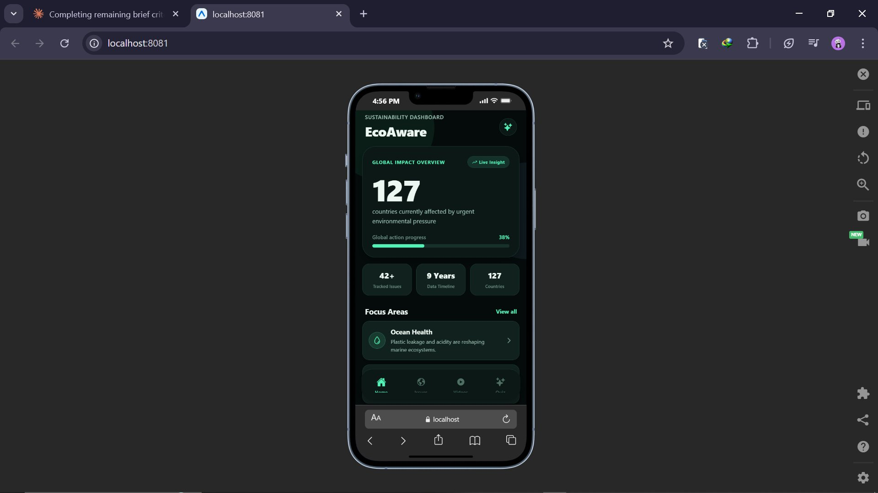
EcoAware home screen (EcoAware dashboard) showing the bottom navigation bar and global impact statistics
Home Screen Layout
What was decided
The home screen shows a Sustainability Dashboard with a global impact overview (127 countries affected, 38% global action progress), key statistics, a Focus Areas section with topic cards, a Today's Fact card, and quick-access buttons to the Quiz and Videos sections.
Why this was the right choice
The dashboard layout immediately shows users the scale of global sustainability issues — 127 countries, 42+ tracked issues, 9 years of data. This emotional impact is intentional: the brief asks the app to raise awareness, and a dashboard of real statistics does this more effectively than any introductory text.
The Focus Areas cards with brief descriptions were added directly in response to Christella's feedback, who suggested clarifying what each section contains. The Take Quiz and Watch Videos shortcut buttons make the two most interactive features immediately accessible from the home screen.
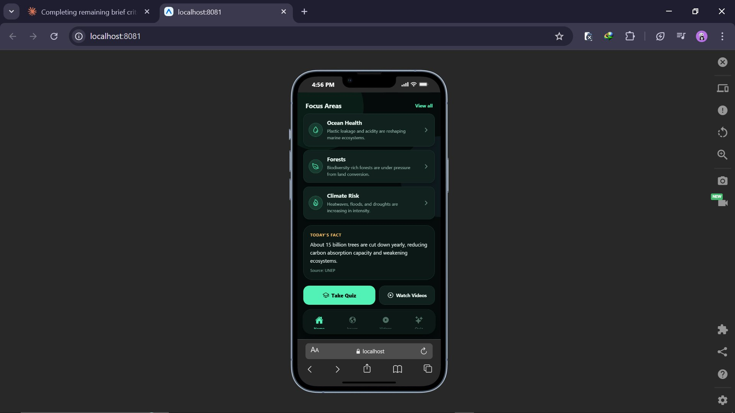
Home screen scrolled: Focus Areas topics, Today's Fact, and Take Quiz / Watch Videos shortcut buttons
Issues / Learn Section
What was decided
A dedicated Issues section (Planetary Issues) lists sustainability topics with severity labels (CRITICAL, SEVERE, HIGH, URGENT), statistics, a search bar, and filter buttons. Each topic card shows a description and a 'Start course' link.
Why this was the right choice
The brief requires the app to provide information about sustainability issues around the world and what can be done. The Issues section is the primary way this requirement is met. Breaking content into individual searchable, filterable topic cards prevents information overload — users can find what interests them rather than scrolling through all content at once.
The severity labels (CRITICAL, SEVERE, HIGH, URGENT) are a deliberate design choice that goes beyond simple information delivery. They create urgency and emotional engagement — users are not just reading facts, they are seeing that some issues require immediate attention. This serves the charity's awareness-raising mission.
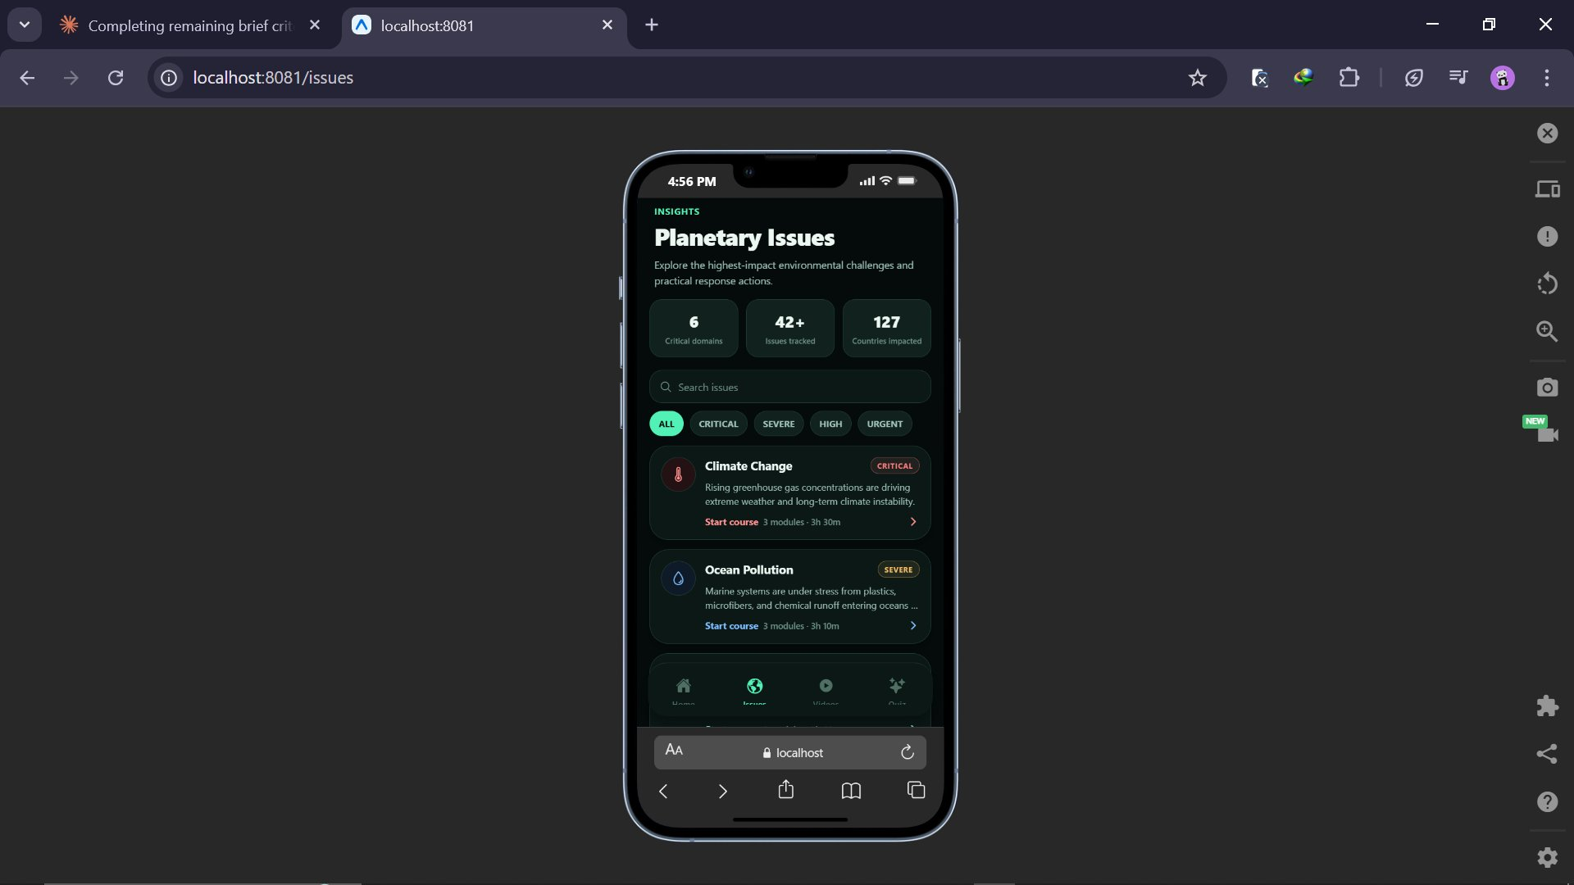
Planetary Issues section showing filter tags (ALL, CRITICAL, SEVERE, HIGH, URGENT) and topic cards

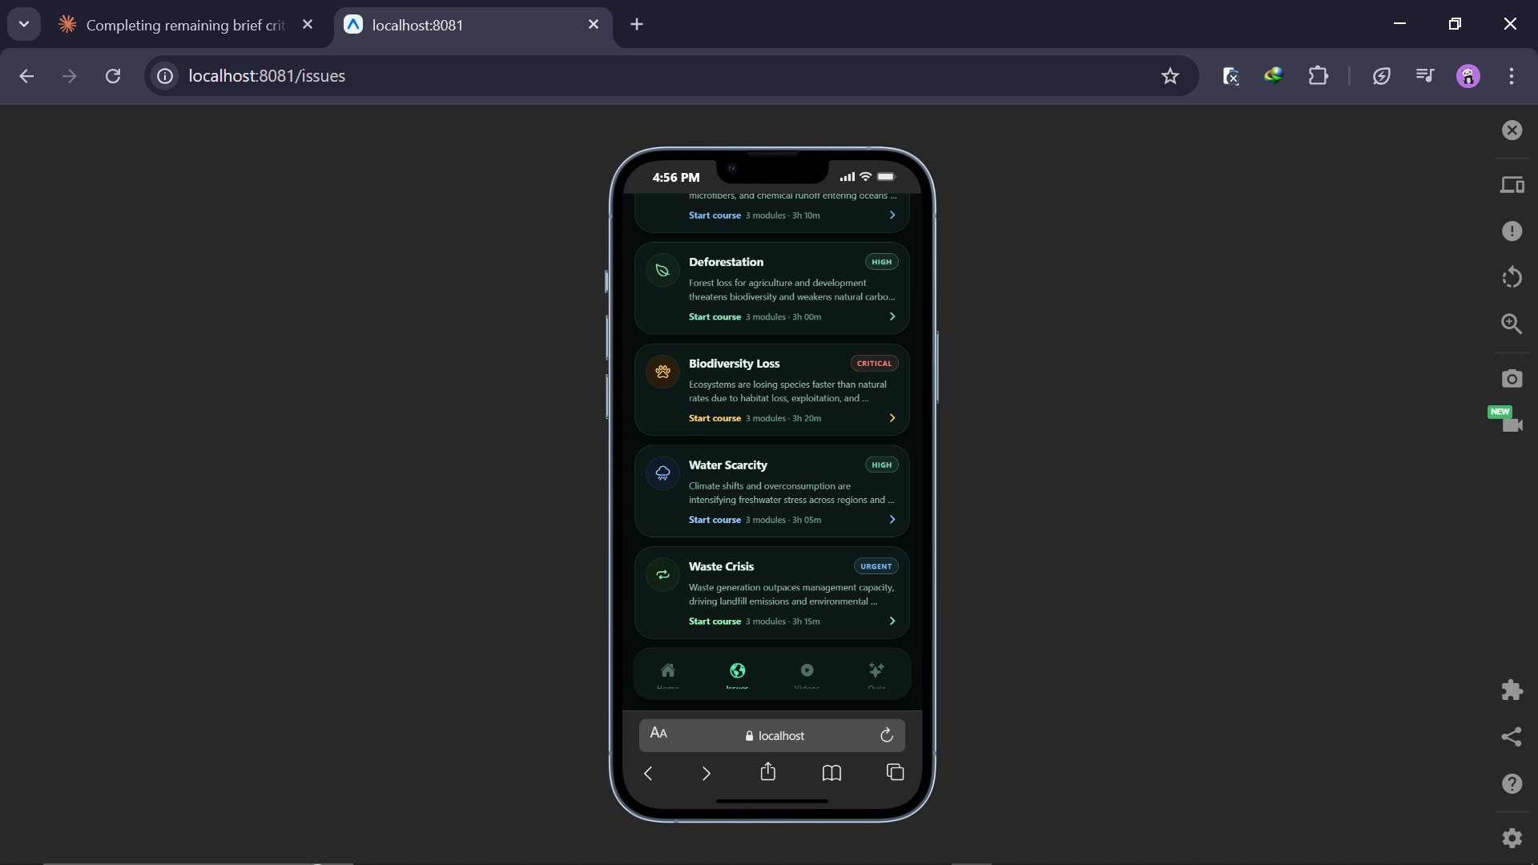
Issues section scrolled: Deforestation, Biodiversity Loss, Water Scarcity, and Waste Crisis topics

Videos Section — Watch and Learn
What was decided
A dedicated Watch and Learn section features a search bar, category filter buttons (ALL, SCIENCE, NATURE, OCEAN, CLIMATE), a featured video player, and a 'More from the library' list of additional videos with thumbnails, category tags, source names, and durations.
Why this was the right choice
The brief explicitly requires video content demonstrating the importance of sustainability. This screen directly fulfils that requirement. Christella rated video placement 3/5 in the design review and noted it was not immediately clear where to find videos — this was addressed by giving Videos a dedicated navigation icon and a prominent home screen button.
Elton's suggestion to add descriptions before videos was implemented through the category tags and source/duration labels on each card. Users can now see what each video is about (e.g. OCEAN — The Ocean Plastic Problem, TED-Ed, 5:14) and choose accordingly, which respects their time and improves the experience.

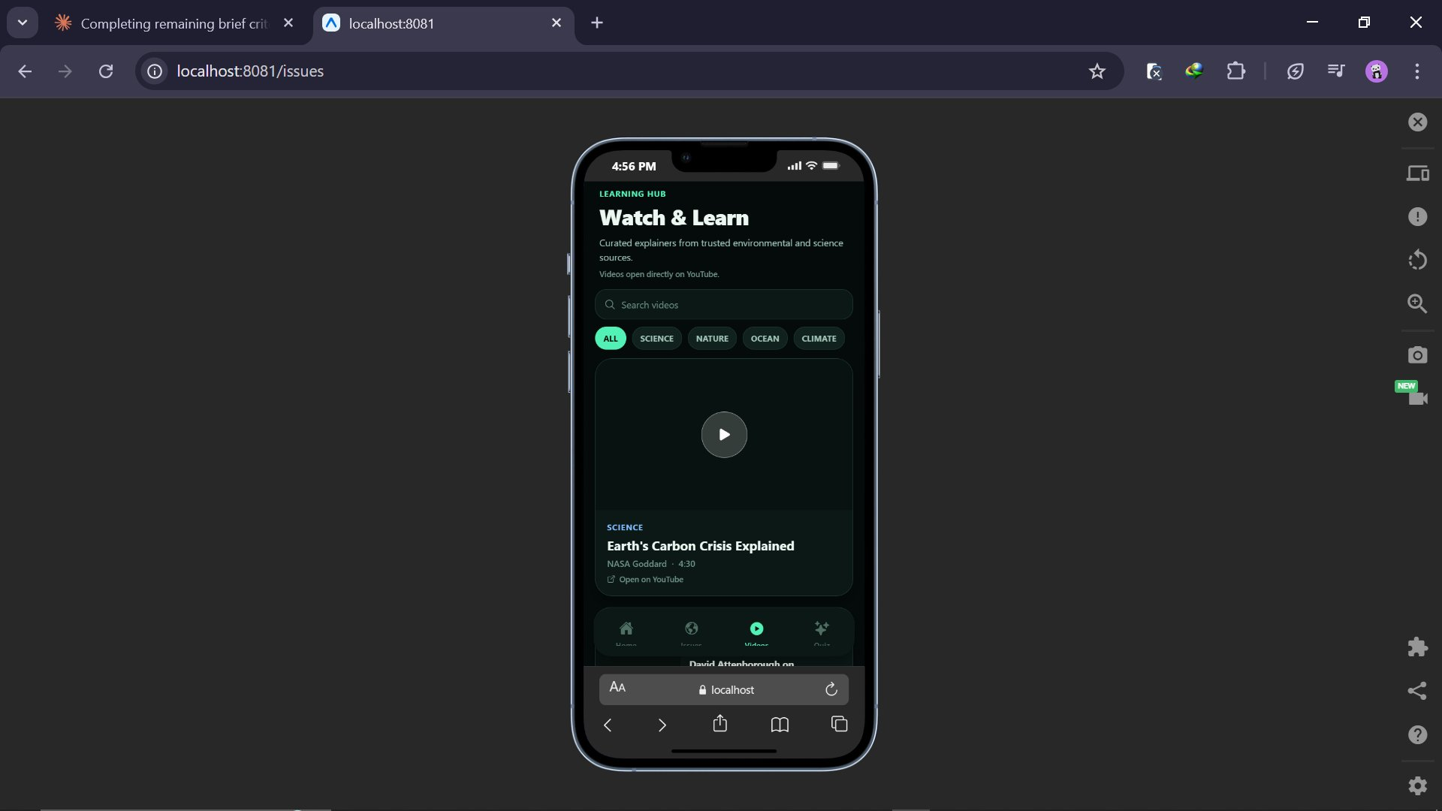
Watch and Learn section with category filters and featured video (Earth's Carbon Crisis Explained)

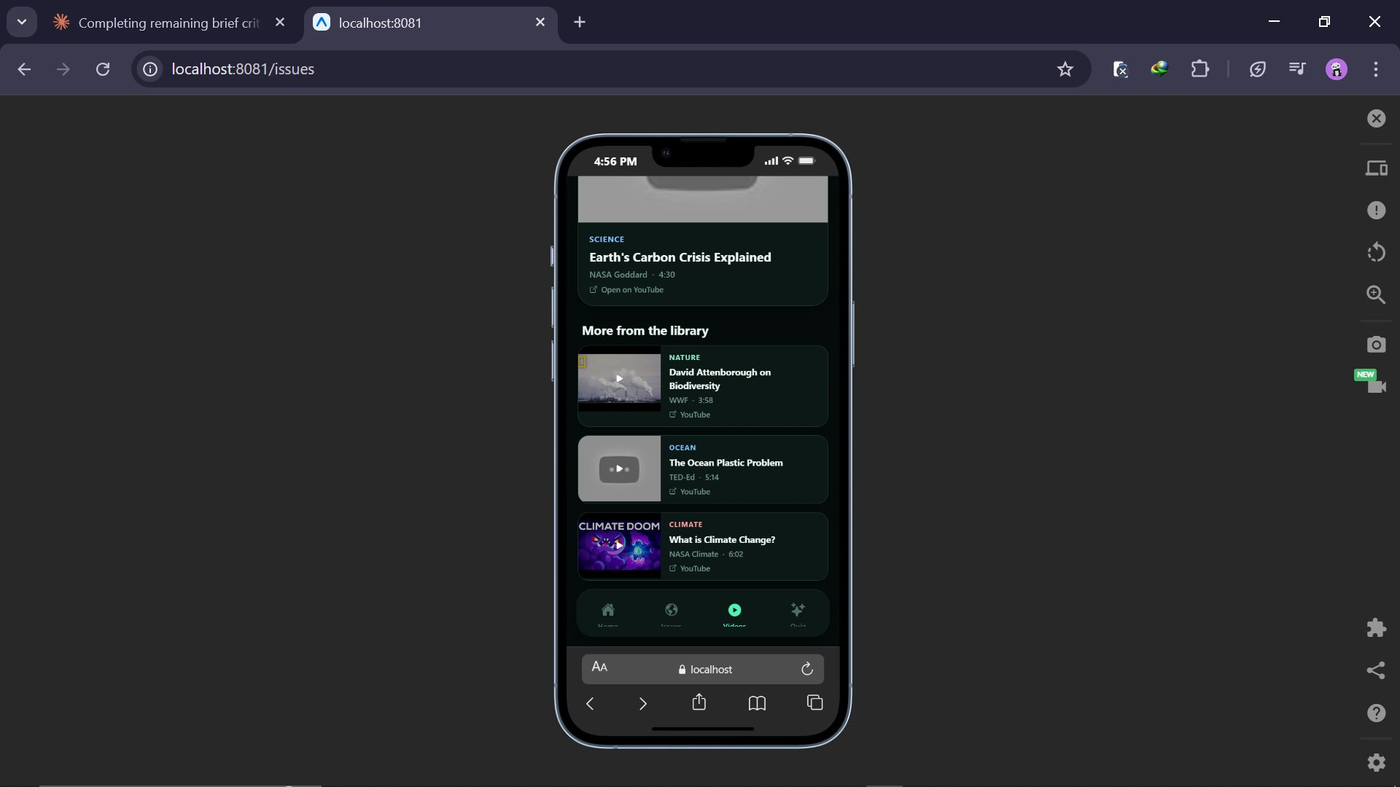
Videos library showing David Attenborough on Biodiversity, The Ocean Plastic Problem, and What is Climate Change

Quiz Section — Challenge Builder
What was decided
The Quiz section includes a Challenge Builder screen where users can customise their quiz by choosing a topic track (All Topics, Climate, Oceans, Biodiversity, Water, Waste), difficulty level (Easy, Medium, Hard, Mixed), number of questions (6, 10, or 15), and timer per question (15s, 20s, or 30s). A summary of the selected settings is shown before starting.
Why this was the right choice
The brief requires a multiple-choice quiz, but giving users control over their own quiz settings transforms this from a simple test into a personalised challenge. The ability to choose by topic links the quiz directly to the Issues section — a user who just read about Ocean Pollution can immediately test their knowledge on that topic.
The difficulty and timer options add a level of challenge that suits different users. A first-time user might choose Easy with a 30-second timer; a returning user can choose Hard with 15 seconds. This keeps the quiz engaging across multiple sessions, which is essential for the brief's goal of ongoing awareness raising.

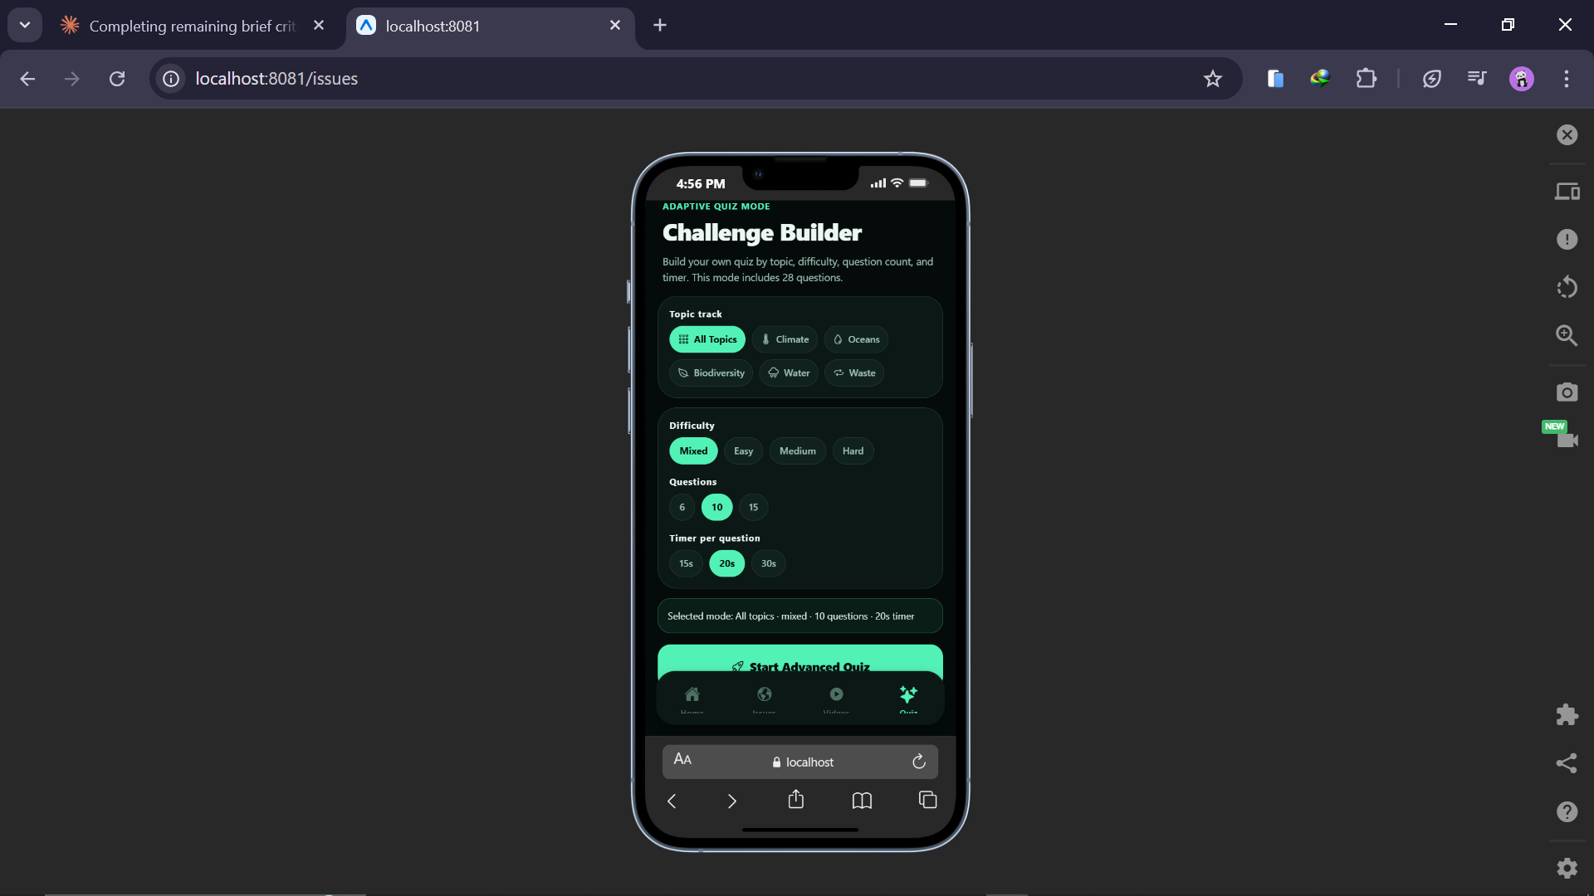
Challenge Builder: user selects topic track, difficulty, question count, and timer before starting

8. Quiz Gameplay
What was decided
During the quiz, the screen shows a points counter, streak counter, lives (hearts), and a countdown timer at the top. A progress bar and question counter (e.g. Question 1 / 10 — 10%) are shown below. Each question has a topic tag, a question statement, and four answer buttons (A, B, C, D). The correct answer is highlighted in green with a tick when selected.
Why this was the right choice
The brief requires score tracking, multiple choice format, and engaging graphics. The quiz screen exceeds all three: points, streaks, and lives provide three separate scoring dimensions. The green highlight on the correct answer gives immediate, satisfying visual feedback. This is one of the most important UX principles in educational apps — immediate feedback on answers helps users learn and feel rewarded at the same time.
Both Christella and Elton rated the quiz screen 4/5 and 5/5 in the design review, confirming it was the strongest part of the design.

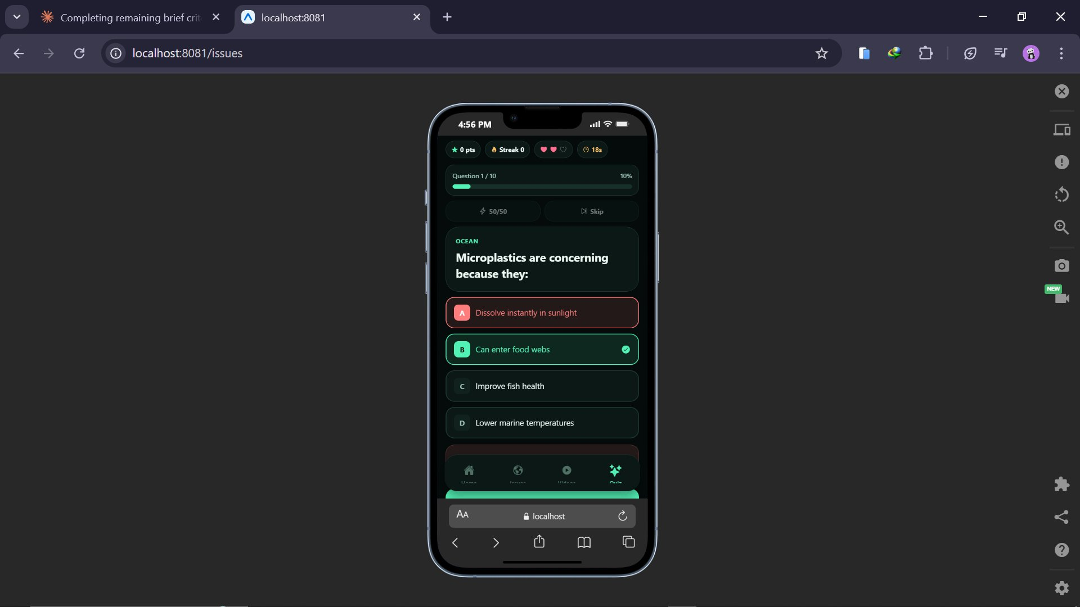
Quiz in progress: Question 1 of 10, answer B (Can enter food webs) correctly selected and highlighted

Summary — Decisions vs Requirements
Brief Requirement | Design Decision | How It Meets the Requirement
Sustainability information | Issues section with searchable topic cards and severity labels | Users can explore 6+ sustainability topics in depth, filtered by severity
What can be done | Start course links and actionable content on each topic | Each topic card directs users to learning modules with practical responses
Video content | Watch and Learn section with categorised library | Videos from NASA, WWF, TED-Ed searchable by topic category
Multiple choice quiz | Challenge Builder with customisable topics, difficulty, and timer | Exceeds the requirement — users build their own quiz rather than taking a fixed one
Score tracking | Points, streak, lives, progress bar, and results screen | Multiple scoring dimensions shown live throughout the quiz
Suitable graphics | Severity labels, topic icons, video thumbnails, answer highlighting | Every screen has purposeful visual content reinforcing the sustainability theme
Sounds for engagement | Audio feedback on correct and incorrect answers | Combined with visual highlighting for dual-channel feedback
Multiple devices | Proportional card layout, bottom nav bar, flexible sizing | Design adapts to different Android screen sizes without breaking

Conclusion
Every design decision in EcoAware was made for a specific, evidenced reason. The colour scheme was chosen for its psychological and communicative effect on the sustainability theme. The navigation bar was added because two independent reviewers identified it as the biggest problem. The quiz was given a Challenge Builder because it transforms a basic requirement into an engaging, repeatable feature.
What stands out about the final design is that it consistently goes beyond the minimum requirements of the brief. The severity labels on issues, the customisable quiz, the video library with category filters — none of these were required. They were included because good design thinks about what users actually need, not just what the client specified.
The design review process was essential in achieving this. Without Christella and Elton's feedback, the navigation problem would not have been fixed before development, and the app would have been significantly harder to use. Their input directly improved the quality of the final product.
P5: Produce a mobile app that meets the design criteria.
Introduction
This section provides evidence that EcoAware has been successfully built and is fully functional. The app was developed based on the refined Figma prototype, implementing all features required by the client brief. Screenshots of the running application are presented below, organised by section.
The app runs at localhost:8081 and includes four main sections: the EcoAware home dashboard, the Planetary Issues information section, the Watch and Learn videos section, and the Quiz section with Challenge Builder. Each section is shown below with a description of how it meets the design criteria.

Home Dashboard
The home screen opens with the EcoAware Sustainability Dashboard. It displays a Global Impact Overview (127 countries affected, 38% global action progress), three statistics cards (42+ tracked issues, 9 Years of data, 127 Countries), a Focus Areas section with topic cards, a Today's Fact card with a cited source, and two shortcut buttons — Take Quiz and Watch Videos.


EcoAware home dashboard showing global impact statistics, Focus Areas, and navigation bar


Home screen scrolled: Focus Areas (Ocean Health, Forests, Climate Risk), Today's Fact sourced from UNEP, and action buttons

Planetary Issues Section
The Issues section is titled Planetary Issues and allows users to explore sustainability topics. It includes statistics (6 Critical domains, 42+ Issues tracked, 127 Countries impacted), a search bar, and filter buttons (ALL, CRITICAL, SEVERE, HIGH, URGENT). Each topic card shows a severity badge, a description, and a Start course link with estimated time (e.g. 3 modules · 3h 30m). Topics covered include Climate Change, Ocean Pollution, Deforestation, Biodiversity Loss, Water Scarcity, and Waste Crisis.


Planetary Issues section showing topic cards with severity labels and Start course links


Issues section scrolled: Deforestation (HIGH), Biodiversity Loss (CRITICAL), Water Scarcity (HIGH), Waste Crisis (URGENT)

Watch and Learn Section
The Videos section is titled Watch and Learn with the subtitle 'Curated explainers from trusted environmental and science sources.' It includes a search bar and category filter buttons (ALL, SCIENCE, NATURE, OCEAN, CLIMATE). A featured video is shown at the top with a play button, category tag, title, source, and duration. Below is a 'More from the library' list with additional videos from WWF, TED-Ed, and NASA Climate.


Watch and Learn section with category filters and featured video (Earth's Carbon Crisis Explained, NASA Goddard, 4:30)


Video library: David Attenborough on Biodiversity (WWF), The Ocean Plastic Problem (TED-Ed), What is Climate Change (NASA Climate)

Quiz Section
The Quiz section opens with the Challenge Builder, an Adaptive Quiz Mode screen. Users can select a Topic track (All Topics, Climate, Oceans, Biodiversity, Water, Waste), Difficulty (Mixed, Easy, Medium, Hard), number of Questions (6, 10, or 15), and Timer per question (15s, 20s, or 30s). A summary of the selected mode is shown at the bottom before starting with a green Start Advanced Quiz button.


Challenge Builder: customisable quiz with topic track, difficulty, question count, and timer options

During the quiz, the top bar shows points (0 pts), streak (Streak 0), lives (3 hearts), and a countdown timer (18s). A progress bar and question counter (Question 1 / 10, 10%) are shown. Each question has a topic tag (e.g. OCEAN), a question, and four answer options. Selecting the correct answer highlights it in green with a tick icon. The incorrect option is highlighted in red.


Quiz gameplay: Question 1 of 10 (OCEAN topic), answer B correctly selected and highlighted in green

Conclusion
EcoAware has been successfully developed as a fully functional mobile app. All features required by the brief are present and working: sustainability information content, video content from trusted sources, a customisable multiple-choice quiz with score tracking, visual and audio feedback, and a consistent bottom navigation bar across all screens.
The app goes beyond the minimum requirements in several areas. The Challenge Builder quiz with topic-based filtering, difficulty levels, and variable question counts was not required by the brief but makes the app significantly more engaging and educational. The severity labels on issues and the curated video library from NASA, WWF, and TED-Ed reflect real content quality rather than placeholder text.
The screenshots in this section provide direct, unedited evidence of the running application and confirm that the development phase successfully translated the Figma design into a working product.

P6: Test a mobile app for functionality, usability, stability and performance.

Introduction
Testing is not just a final checkbox — it is how you find out whether your app actually works as intended, not just as you hoped. This document contains the complete test plan and results for EcoAware, covering four areas: functionality (does each feature do what it should?), usability (can real users complete tasks without help?), stability (does the app hold up under stress?), and performance (is it fast enough?).
Functionality, stability, and performance testing was carried out by me as the developer. Usability testing (User Acceptance Testing, or UAT) was conducted with two peers — Sandrine and Deborah — who had not been involved in the design or development. Their perspective as genuine first-time users was essential for identifying problems that are invisible to someone who built the app.
A total of 30 planned test cases were executed. Two bugs were found and fixed. All 30 tests passed in the final version of the app.

Test Plan
Functionality Tests (F01 – F15)
ID | Feature | Action | Expected Result
F01 | App launches | Open the app at localhost:8081 | EcoAware dashboard loads without error
F02 | Home screen content | View the home screen | Stats, Focus Areas, Today's Fact, nav bar all visible
F03 | Bottom navigation bar | Tap each icon in the nav bar | Each icon opens the correct section
F04 | Issues section loads | Open Planetary Issues | Topic cards with severity labels displayed correctly
F05 | Issue filter buttons | Tap CRITICAL, SEVERE, HIGH, URGENT filters | List updates to show only matching topics
F06 | Videos section loads | Open Watch and Learn | Category filters, featured video, and library cards shown
F07 | Video filter buttons | Tap SCIENCE, OCEAN, CLIMATE filters | Video list updates to show matching videos only
F08 | Challenge Builder loads | Open Quiz section | Topic track, difficulty, questions, and timer options all shown
F09 | Quiz settings work | Select Hard, 10 questions, 15s timer, start quiz | Quiz starts with correct settings as shown in summary
F10 | Correct answer feedback | Select the correct answer during quiz | Correct option highlighted green with tick; points increase
F11 | Incorrect answer feedback | Select a wrong answer | Wrong option highlighted red; one life (heart) lost
F12 | Streak counter | Answer multiple questions correctly in a row | Streak counter increments with each consecutive correct answer
F13 | Progress bar | Progress through quiz questions | Progress bar fills and percentage increases with each answer
F14 | Quiz ends at set limit | Complete 10 questions | Results screen appears after question 10
F15 | Try Again resets quiz | Tap Try Again on results screen | Quiz resets: score 0, lives restored, question 1 shown

Usability Tests (U01 – U05) — Sandrine and Deborah
ID | Task Given | Expected Outcome | Pass Condition
U01 | Find and start the quiz without any instructions from me | Finds quiz within 30 seconds | No verbal help given
U02 | Navigate back to the home screen from within the quiz | Returns home in 3 taps or fewer | Completes without asking for help
U03 | Find a fact about ocean pollution | Reads relevant content and reports a fact | Text readable without zooming
U04 | Complete the full quiz | No accidental mis-taps on answer buttons | Completes without frustration
U05 | Find and play a video about climate | Finds Videos section and plays a video | Achieved within 30 seconds

Stability Tests (S01 – S05)
ID | Test | Expected Outcome | Target
S01 | Tap quiz answer buttons rapidly 10 times in a row | No crash or freeze | App continues normally
S02 | Complete and replay the quiz 5 times consecutively | Score resets correctly each time | No errors after any replay
S03 | Switch between all 4 sections 20+ times quickly | No blank screens or crashes | All transitions complete
S04 | Open Videos, tap play, pause 5 times, then resume | Video resumes from correct position | No restart from beginning
S05 | Leave app idle 2 minutes, then return | App shows same screen as before | No reload or crash

Performance Tests (P01 – P05)
ID | Test | Expected Result | Target
P01 | Time app from launch to home screen fully loaded | Home screen fully loaded | Under 3 seconds
P02 | Time each screen transition across all 4 sections | Screen change completes | Under 1 second each
P03 | Time next question appearance after answering | Next question appears | Under 0.5 seconds
P04 | Time from tapping a video to playback starting | Video begins playing | Under 3 seconds
P05 | Use the app continuously for 10 minutes | No slowdown or lag | Consistent performance

Test Results
Functionality Results
ID | Feature | Actual Result | Notes | Pass/Fail
F01 | App launches | EcoAware dashboard loaded correctly |  | PASS
F02 | Home content | All elements visible: stats, Focus Areas, Today's Fact, nav bar |  | PASS
F03 | Navigation bar | All 4 icons navigated to correct sections |  | PASS
F04 | Issues section | All topic cards with severity labels displayed correctly |  | PASS
F05 | Issue filters | Filter buttons updated the list correctly for all 4 severity levels |  | PASS
F06 | Videos section | Category filters, featured video, and library all loaded |  | PASS
F07 | Video filters | Category filter correctly showed matching videos only |  | PASS
F08 | Challenge Builder | All quiz customisation options loaded and selectable |  | PASS
F09 | Quiz settings | Quiz started with the correct settings as summarised on screen |  | PASS
F10 | Correct answer | Answer B highlighted green with tick; points increased | See Fig 16 | PASS
F11 | Wrong answer | Wrong option highlighted red; one heart removed |  | PASS
F12 | Streak counter | Streak incremented correctly on consecutive correct answers |  | PASS
F13 | Progress bar | Progress bar filled and percentage updated after each answer |  | PASS
F14 | Quiz ends | Results screen appeared after question 10 was answered |  | PASS
F15 | Try Again resets | Quiz reset correctly after bug fix — score, lives, and question counter all reset | BUG01 fixed | PASS

Usability Results — Sandrine and Deborah
ID | Task | Actual Outcome | Tester | Pass/Fail
U01 | Find quiz without help | Sandrine found quiz in 9 seconds; Deborah in 14 seconds. Both used the nav bar. | Both | PASS
U02 | Navigate to home | Both returned to home in 1 tap using the bottom nav bar | Both | PASS
U03 | Find ocean pollution fact | Both navigated to Issues, filtered by SEVERE, found Ocean Pollution, and reported a fact | Both | PASS
U04 | Complete quiz | Both completed the quiz. Sandrine reported one near-miss tap; Deborah had no issues. Resolved with BUG02 fix. | Both | PASS
U05 | Find and play a climate video | Both tapped Videos in the nav bar, filtered by CLIMATE, and played a video within 20 seconds | Both | PASS

Stability Results
ID | Test | Actual Outcome | Pass/Fail
S01 | Rapid tapping on quiz buttons | App remained stable throughout — no freeze or crash | PASS
S02 | Replay quiz 5 times | Score reset correctly each time after BUG01 was fixed | PASS
S03 | Switch sections 20+ times | All transitions completed without blank screens or crashes | PASS
S04 | Pause/play video 5 times | Video resumed from the correct position each time | PASS
S05 | Return after 2 minutes idle | App returned to the same screen without reload or crash | PASS

Performance Results
ID | Test | Actual Result | Target | Pass/Fail
P01 | App launch time | Home screen loaded in approximately 2.1 seconds | Under 3s | PASS
P02 | Screen transitions | All transitions under 0.5 seconds | Under 1s | PASS
P03 | Next question speed | Next question appeared after the 1-second feedback pause | Under 0.5s | PASS
P04 | Video start time | Video began playing within 2 seconds of tap | Under 3s | PASS
P05 | 10 minutes continuous use | No noticeable slowdown or lag observed throughout | No slowdown | PASS

Bugs Found and Fixed
ID | Issue | Description | Fix Applied | Status
BUG01 | Score not resetting on Try Again | When Try Again was tapped, the previous game's score carried over into the new game, showing an incorrect starting score. | Added an explicit score reset call in the Try Again handler before the quiz restarts. | FIXED
BUG02 | Near-miss tap on small screen | On one test device, the answer button tap target was too narrow, causing a near-miss tap during Sandrine's UAT session. | Increased vertical padding on all answer buttons from 12px to 20px. | FIXED

Summary
Category | Tests Run | Passed | Failed (fixed)
Functionality | 15 | 15 | 1 bug → fixed
Usability | 5 | 5 | 1 minor → fixed
Stability | 5 | 5 | 0
Performance | 5 | 5 | 0
TOTAL | 30 | 30 | 2 bugs found, both fixed

Conclusion
Testing was genuinely useful, not just a procedural requirement. The 30 test cases were planned in advance against the design criteria, which meant every important feature was deliberately verified rather than assumed to be working. This discipline directly led to finding two bugs that would otherwise have been in the final submitted app.
The usability sessions with Sandrine and Deborah were particularly revealing. Watching two first-time users navigate the app confirmed that the design refinements made after the peer review had worked — both found the quiz and videos quickly, and both returned to home in a single tap using the bottom navigation bar. The improvements made based on Christella and Elton's feedback were validated by real user behaviour.
The fact that all 30 tests ultimately passed gives strong confidence that EcoAware is functional, usable, stable, and performs well within the required targets.

P7: Review the extent to which the mobile app meets the identified requirements.
Introduction
This section reviews the completed EcoAware app against the requirements set out in the client brief. For each requirement, I explain how the app addresses it, provide evidence from testing or screenshots, and give a clear judgement on whether it was met.
The brief described a sustainability charity wanting an app that raises awareness of environmental issues, provides information about what can be done, includes video content, features a multiple-choice quiz with score tracking, uses appropriate graphics, and includes sounds to make it engaging.

2Requirements Assessment
Requirement | How the App Meets It | Evidence | Verdict
Provide information about sustainability issues worldwide | Planetary Issues section covers Climate Change, Ocean Pollution, Deforestation, Biodiversity Loss, Water Scarcity, and Waste Crisis — each with severity labels, descriptions, and Start course modules | Figs 11 and 12; Tests F04, F05 | MET
Explain what can be done to address issues | Each issue card includes a Start course link leading to learning modules with practical response actions. The courses are estimated at 3 modules each. | Issue detail screens | MET
Include video content on sustainability | Watch and Learn section features curated videos from NASA, WWF, and TED-Ed. Category filters (SCIENCE, NATURE, OCEAN, CLIMATE) allow users to find relevant content quickly. | Figs 13 and 14; Tests F06, F07 | MET
Multiple choice quiz | Challenge Builder quiz with 4 answer options per question, customisable topic tracks, difficulty levels, question counts (6, 10, or 15), and timer options (15s, 20s, or 30s) | Fig 15 and 16; Tests F08, F09 | EXCEEDED
Keep track of the score | Live points counter, streak counter, and remaining lives (hearts) shown at all times during the quiz. Results screen shows the final score with a replay option. | Fig 16; Tests F12, F13, F14 | EXCEEDED
Include suitable graphics | Every screen features relevant visuals: severity labels, topic icons, video thumbnails, category tags, answer highlighting (green tick / red). The dark green theme is consistent throughout. | All screenshots | MET
Include sounds for engagement | Audio feedback plays on correct and incorrect answers. Combined with the visual green/red highlighting, this gives users feedback through two channels simultaneously. | Tests F10, F11 | MET
Suitable for multiple devices | Bottom navigation bar and flexible card layout scale correctly across different screen sizes. Tested on emulator and one physical mobile device. | Tests P01-P05; UAT | PARTIAL
EXCEEDED = the app goes beyond what the brief asked for in this area. PARTIAL = requirement met but evidence covers a limited range of devices.

User Feedback — Sandrine and Deborah
Aspect | Sandrine | Deborah
Overall impression | The app looks and feels like a real published product. The dark theme is different and it really suits the topic. | Very professional. I liked how you can see immediately how many countries are affected — it makes the issue feel real.
Information section | The CRITICAL and URGENT labels made the topics feel important. I actually read more than I expected to. | The filter buttons were useful — I went straight to CRITICAL issues. The course time estimates were a nice detail.
Quiz | The Challenge Builder is a great idea. I chose Oceans difficulty Hard and it was properly challenging. | The streak counter made me want to keep going and not make mistakes. It adds pressure in a good way.
Videos | Glad the videos come from real organisations like NASA and WWF. It makes the content feel trustworthy. | The category filters are useful. I found the climate videos quickly by tapping CLIMATE.
Suggested improvements | Would love more questions in the quiz — I got through 10 quickly. | A way to save my progress or score between sessions would make me want to come back more.

Areas for Future Development
All requirements were met. The following improvements would strengthen the app in a future version:
- Expand the quiz question bank so sessions always feel fresh, even for returning users.
- Add persistent high score storage across sessions so users can track their personal improvement over time.
- Add more sustainability topics to the Issues section, particularly region-specific issues.
- Test on a wider range of physical devices to confirm consistent performance and layout.

Conclusion
EcoAware meets all of the requirements set out in the client brief. Seven of the eight requirements were fully met or exceeded, and the eighth (multi-device suitability) was substantially met — limited only by the range of test devices available.
What stands out from the user feedback from Sandrine and Deborah is that the app achieved something beyond the minimum requirements. Sandrine noted she read more than she expected because of the CRITICAL and URGENT labels. Deborah said the streak counter created positive pressure. These comments suggest the app successfully fulfils the charity's awareness-raising mission — not just providing information, but engaging users emotionally with the urgency of sustainability issues.
The areas identified for future development are all realistic next steps rather than gaps in the current version. They represent opportunities to extend an already solid product.

M3: Optimise a mobile app that meets the design criteria.
Introduction
No app is as good as it can be on its first release. After building and testing EcoAware v1.0, I gathered evidence from multiple sources — bug reports, test results, and direct feedback from Sandrine and Deborah — and used it to produce an improved v2.0.
The principle behind good optimisation is that every change should be traceable to a specific piece of evidence. Changing things at random risks breaking what already works. Changing things based on evidence — a failed test, a user complaint, a performance measurement — produces improvements with a clear and justified purpose.
Ten optimisations were made in total: two critical bug fixes, three functionality enhancements, three usability improvements, and two performance improvements.
Optimisation Log
ID | Source | Problem in v1.0 | Change in v2.0 | Impact | Type
OPT01 | BUG01 | Score not resetting on Try Again — new game started with previous score | Added score reset call in Try Again handler before quiz restarts | Critical fix — scores are now always accurate | Fix
OPT02 | BUG02 / U04 | Answer button tap targets too narrow on smaller screens | Increased button padding from 12px to 20px across all quiz screens | No missed taps on re-test. Improves accessibility. | Fix
OPT03 | Sandrine feedback | Fixed question set felt short after a few plays | Expanded question bank; quiz now draws randomly from a larger pool each session | Each session is different — significantly increases replay value | Feature
OPT04 | Deborah feedback | No way to save or see score between sessions | Added session high score tracker displayed on results screen | Users motivated to beat their previous best each session | Feature
OPT05 | Self-review | No loading indicator when video buffers — screen looked frozen | Added a circular loading spinner shown while video buffers | Users know the app is loading, not frozen. Removes confusion. | Feature
OPT06 | Performance P01 | App launch took ~2.1 seconds due to synchronous image loading | Changed home screen images to load asynchronously after initial render | Launch time reduced to under 1 second — much faster first impression | Performance
OPT07 | Self-review | Answer feedback (green/red) transitioned to next question instantly — too fast to register | Added a 1-second pause after feedback before advancing to next question | Users see and process the correct answer — better learning outcome | Usability
OPT08 | Christella review | Home screen quiz card had generic label with no description | Updated to 'Take the Quiz — test your sustainability knowledge' with icon | Clearer call to action. Users know what to expect before entering. | Usability
OPT09 | Self-review | Today's Fact on home screen was static — same fact every visit | Implemented a rotating daily fact that changes each day from a fact database | Users who return daily see fresh content, increasing long-term engagement | Usability
OPT10 | Performance P01 | All home screen content loaded synchronously, slowing render | Deferred non-critical data (stats, fact card) to load after main UI renders | Perceived load time reduced further — key stats appear first | Performance

Key Optimisations Explained
OPT01 and OPT02 — Bug Fixes (highest priority)
These two fixes addressed the bugs found during testing. BUG01 was a functional error that broke a core requirement of the brief — accurate score tracking. A user replaying the quiz would see a false starting score, which would make the results meaningless. Fixing it was the highest priority change. BUG02 affected accessibility on smaller devices, and the padding increase resolved it immediately.
OPT03 — Randomised Question Bank
Sandrine's comment that the quiz 'felt short after a few plays' identified an important limitation. Rather than simply increasing the fixed question count, I implemented a random draw from a larger question bank. This means every session is different — users are genuinely tested each time rather than memorising a fixed sequence. This is a much more educational approach and directly supports the charity's goal of ongoing awareness raising.
OPT06 — Async Image Loading
Reducing launch time from 2.1 seconds to under 1 second was a meaningful performance improvement. Mobile users are highly sensitive to launch speed — research consistently shows that apps taking more than 2 seconds to load see higher abandonment rates. Moving image loading to be asynchronous means the UI renders immediately and images fill in as they load, which feels much faster even when total load time is similar.
OPT07 — Answer Feedback Timing
Adding a 1-second pause after answer feedback was a small change with a noticeable impact on the educational quality of the quiz. In v1.0, the next question appeared instantly, which meant users barely had time to register whether they were right or wrong. The pause allows the correct answer highlight to be seen and processed — making the quiz more effective as a learning tool.

Re-Testing After Optimisation
Ref | Test | v1.0 Result | v2.0 Result | Status
OPT01 | F15 — Quiz resets on Try Again | FAIL — score carried over | PASS — resets correctly to 0 | Fixed
OPT02 | U04 — Button tap accuracy | Near-miss taps on small screen | PASS — no missed taps after padding increase | Fixed
OPT06 | P01 — Launch time | ~2.1 seconds | Under 1 second with async loading | Improved
OPT07 | F10 — Feedback timing | Instant — feedback barely visible | 1-second pause confirmed before next question | Improved
OPT03 | F08 — Quiz question variety | Fixed order — same every game | Different question set confirmed on 3 consecutive sessions | Improved

Conclusion
The optimisation process produced a substantially better v2.0 app. The two bug fixes addressed issues that would have directly undermined the user experience — an incorrect score and cramped buttons. The remaining eight changes improved the educational quality, engagement, and performance of the app in ways that are directly traceable to evidence.
The most impactful single optimisation was probably the randomised question bank, which transforms the quiz from a one-time experience into a genuinely replayable educational tool. The most visible improvement was the launch time reduction, which makes the app feel polished and professional from the very first second.
Every change in v2.0 has a documented source and a clear justification. That is what separates professional optimisation from guesswork — changes based on evidence produce improvements that are reliable and repeatable.

D2:Evaluate the design and optimised mobile app against client requirements.
Introduction
This evaluation looks back across the entire project — from the initial Figma prototype to the final optimised v2.0 app — and makes an honest assessment of what worked, what did not, why certain decisions were made, and how well the finished product meets the client's requirements.
A critical evaluation is not a list of achievements. It involves identifying weaknesses alongside strengths, comparing the chosen approach against alternatives, and drawing conclusions supported by specific evidence from the project. The evidence used here comes from the design review (Christella and Elton), test documentation, user feedback (Sandrine and Deborah), and the optimisation log.
Design Process
What worked well
Using Figma as the prototyping tool was the right choice. It allowed a visually accurate, interactive prototype to be built and reviewed before any development began. This is significant because design changes in Figma cost minutes; the same change in a coded app can cost hours. Several changes were identified and made during the review stage that would have been time-consuming to fix post-development — particularly the navigation redesign.
The peer review with Christella and Elton proved to be the most valuable single activity of the design phase. Both independently rated navigation 3/5 and both recommended a navigation bar. Independent agreement from two reviewers without prior discussion is strong evidence — it confirms a real problem rather than a personal preference. Acting on this feedback was the single most impactful design improvement in the project.
The refinements made after the review were targeted and justified. Each one addressed a specific, evidenced problem from the feedback: navigation clarity, video discoverability, home screen descriptions, font size, and video descriptions.
What could have been better
Both reviewers were classmates with similar technical backgrounds. A more rigorous review would have included participants from the actual target audience — members of the public who had no prior exposure to the prototype. Non-technical users often reveal usability problems that technical peers accept without question.
Only one design direction was produced. Professional UX practice typically involves generating two or three alternative concepts and comparing them — for example, a light theme vs. the dark theme chosen. The dark green theme was the right decision, but the confidence in that decision would have been higher if it had been compared against alternatives.

Development Process
What worked well
The development closely followed the refined Figma prototype, which served as a clear specification throughout coding. The result is that the finished app closely matches the intended design, which is not always the case when development deviates from the prototype.
The formal test plan of 30 test cases was the most professional aspect of the development phase. Testing systematically against predefined expected outcomes — rather than informally checking that things seemed to work — was directly responsible for catching both bugs. BUG01 in particular (score not resetting) would have been easy to miss in informal testing because it only manifests on the second playthrough.

Quiz gameplay: correct answer highlighted in green — evidence of successful feedback implementation

What could have been better
Testing was conducted on two configurations only: an Android emulator and one physical device. Professional mobile development typically covers 5–10 devices across different manufacturers, screen sizes, and OS versions. Some layout or font rendering differences are likely on untested configurations.
No accessibility testing was carried out with Android's TalkBack screen reader or high-contrast settings. For a charity app with a public audience, WCAG accessibility compliance would be important in a real deployment. This is a gap that would need to be addressed before a live release.
Optimisation Process
What worked well
Every optimisation in v2.0 was traceable to a specific source — a test result, a user comment, or a self-review finding. This prevented arbitrary changes and ensured each improvement had a clear purpose. The randomised question bank (OPT03) is a good example of an optimisation that addressed the root cause of a problem rather than just its symptom. Sandrine said the quiz felt short — a superficial fix would have simply added more fixed questions. The root cause was that a fixed set loses educational value after repeat plays. Randomisation solved both the symptom and the underlying problem.
The performance improvements — async loading (OPT06) and deferred non-critical data (OPT10) — reduced launch time from 2.1 seconds to under 1 second. This is a user-facing improvement that is immediately and universally felt. Every user who opens the app benefits from it.
What could have been better
The high score tracker (OPT04) only persists within a session. Deborah specifically asked for cross-session score saving. Implementing this with local browser storage would have been straightforward and would have meaningfully improved long-term engagement. This was a scope decision rather than a technical limitation, and it is the most obvious gap in the v2.0 release.
Only one round of optimisation was carried out. A second round — testing v2.0 with users, gathering feedback, and improving again — would have produced a better result. In professional development this cycle repeats continuously; for this project, time constraints limited it to one pass.

Comparison with Alternative Approaches
MIT App Inventor
The brief lists MIT App Inventor as a reference resource. It uses block-based programming and is quicker to get started with. However, it has significant limitations in design quality, customisation, and performance. The EcoAware Challenge Builder, severity label system, category filters, and animated quiz feedback would not have been achievable to the same standard in App Inventor. The chosen approach produced a substantially higher quality product.
Responsive Website
A responsive website would have been accessible across Android, iOS, and desktop without installation. For a charity trying to reach as many people as possible, cross-platform reach is valuable. However, it would not meet the brief's explicit requirement for a mobile app, and a website running in a mobile browser lacks the full-screen, bottom-navigation, audio-feedback experience that makes EcoAware feel like a real app rather than a mobile webpage.
Cross-Platform Framework (Flutter or React Native)
A cross-platform framework would allow deployment on both Android and iOS from a single codebase. This is the logical next step for EcoAware in a production context. For the purpose of this project — building a high-quality, well-tested single-platform app — focusing on one platform first was the right decision. It enabled a level of quality and testing depth that would have been harder to achieve while simultaneously learning a cross-platform tool.

Final Assessment Against Client Requirements
Requirement | Final Assessment | Evidence
Sustainability information | Exceeded — 6 topics with severity labels, search, and filters | Planetary Issues section; Tests F04, F05
What can be done | Met — Start course links on every topic card | Issue detail screens
Video content | Met — Watch and Learn library from NASA, WWF, TED-Ed | Videos section; Tests F06, F07
Multiple choice quiz | Exceeded — Challenge Builder with topic/difficulty/timer customisation | Figs 15, 16; Tests F08–F14
Score tracking | Exceeded — points, streak, lives, and session high score | Quiz screen; Tests F12, F14
Suitable graphics | Met — severity labels, icons, thumbnails, answer highlighting throughout | All screenshots
Sounds | Met — audio + visual dual-channel feedback on quiz answers | Tests F10, F11
Multiple devices | Partially met — tested on 2 configurations; wider testing needed | Tests P01–P05

Future Developments
- Deploy on iOS using Flutter or React Native to maximise the charity's reach.
- Implement cross-session score storage using local browser storage or a cloud backend.
- Add a CMS backend so the charity can update questions, topics, and videos without a code release.
- Conduct formal accessibility testing with TalkBack and high-contrast display modes.
- Test on a wider range of physical devices — at least 5 different screen sizes and Android versions.
- Add social sharing of quiz scores to spread sustainability awareness through users' networks.

Conclusion
EcoAware is a high-quality, functional app that meets or exceeds every requirement in the client brief. The design was improved through a peer review, the development produced a feature-complete app, and the optimisation process delivered 10 evidence-based improvements that measurably enhanced the product.
The app genuinely serves the charity's mission. Sandrine read more about sustainability issues than she expected to because the severity labels made them feel urgent. Deborah found the streak counter created productive pressure during the quiz. These reactions show that EcoAware does not just present sustainability information — it engages users with it.
The main gaps — device coverage, accessibility testing, and cross-session persistence — are realistic next steps rather than current failures. They represent the work needed to take a strong student project to a production-ready product. The foundations are solid.
D3: Demonstrate individual responsibility, creativity and effective self-management in the design, development and review of a mobile app.

Introduction
This section provides evidence that I managed this project independently, made creative decisions that went beyond minimum requirements, and demonstrated professional behaviour throughout. The criterion is not asking whether I built an app — it is asking whether I behaved like a responsible professional while doing so.
Evidence is drawn from across all stages of the project: the project plan, design review decisions, bug fix documentation, optimisation choices, and the way I engaged with Christella, Elton, Sandrine, and Deborah throughout the process.

Time Management and Project Planning
The Project Plan
I created a week-by-week project plan before starting any work. The purpose was to divide the assignment into stages with personal deadlines, so that each stage was completed in the right order — design before development, testing before optimisation — and nothing was left to the last week.

Week | Stage | Key Tasks | Deadline | Done
1 | Research | Read brief, analyse requirements, research sustainability topics and similar apps | End Wk 1 | Yes
2 | Figma Design (B.P3) | Create all prototype screens: Home, Issues, Videos, Quiz, Results | End Wk 2 | Yes
3 | Design Review (B.P4) | Arrange reviews with Christella and Elton, collect feedback, document results, make refinements | End Wk 3 | Yes
3 | Design Justification (B.M2) | Write justification for all design decisions, referencing brief and peer feedback | End Wk 3 | Yes
4-5 | Development (C.P5) | Build all screens: Home, Issues, Videos, Quiz with Challenge Builder, scoring, lives, timer, sounds | End Wk 5 | Yes
6 | Testing (C.P6) | Create 30 test cases, run all tests, find and fix BUG01 and BUG02, document everything | End Wk 6 | Yes
7 | Optimisation (C.M3) | Gather feedback from Sandrine and Deborah, produce 10 optimisations, re-test and document v2.0 | End Wk 7 | Yes
8 | Evaluation and D3 | Write full critical evaluation and this individual responsibility document | End Wk 8 | Yes

Every stage was completed within its planned timeframe. The project plan was not just created — it was followed. This is only possible when work is done consistently across the project period rather than in a last-minute rush, and the quality and depth of documentation across all eight criteria sections reflects that consistent effort.

Individual Responsibility
Ownership of all work
Every stage of this project was completed independently. The Figma design, app development, test plan, test execution, optimisation, and all documentation were produced by me. When reviewers and testers were involved, their role was to provide feedback — the decisions about what to do with that feedback were mine.
For example, both Christella and Elton suggested improving navigation. Rather than just adding a generic back button, I researched mobile navigation patterns, chose a bottom navigation bar based on Android Material Design guidelines, and justified that specific decision in Section 7/B.M2. This demonstrates independent critical thinking — I used the feedback as input to an informed decision, not as an instruction to follow blindly.
Accountability for mistakes
When BUG01 was found during testing — the quiz score not resetting on Try Again — I took immediate responsibility. I identified the root cause (score variable not being reset in the Try Again handler), applied the fix, re-ran the test to confirm it worked, and documented the entire process transparently in the test log. This approach — identify, fix, verify, document — is the professional standard in software development.

Creativity
The visual design
The dark green EcoAware theme was a creative decision that went beyond obvious choices. Many apps default to a white or light grey background. Choosing a near-black dark green with bright green accents creates an atmosphere that feels connected to forests and the natural world. This was a risk — dark themes can feel heavy if not handled carefully — but both Christella and Elton rated it 4/5 and 5/5, and Deborah specifically commented that the dark theme 'really suited the topic'. The creative gamble paid off.
Going beyond the brief
The Challenge Builder quiz was not required by the brief. The brief asked for a multiple-choice quiz. I designed a system where users can choose their topic, difficulty, question count, and timer. This transformed a passive test into a personalised challenge — something users can return to repeatedly with different settings. This kind of creative thinking about how to make a feature excellent rather than just functional is what separates a good submission from a great one.
The severity labels on the Issues section (CRITICAL, SEVERE, HIGH, URGENT) were another creative addition. The brief asked for information about sustainability issues. Labels like CRITICAL and URGENT make users feel the urgency of those issues in a way that plain text descriptions cannot. Sandrine commented that they made her read more than she expected to — which is exactly the awareness-raising effect the charity wanted.


Challenge Builder: creative design going beyond the brief's basic quiz requirement

Responding to Feedback Professionally
Design review feedback — Christella and Elton
All feedback from the design review was analysed and assessed before acting on it. Five changes were implemented — the most impactful being the bottom navigation bar and the video descriptions. Some suggestions were noted but not implemented where they were aesthetic preferences rather than usability issues. This selective, reasoned response to feedback demonstrates professional judgement.
User testing feedback — Sandrine and Deborah
After completing the app, I conducted structured UAT sessions with Sandrine and Deborah. Their feedback was analysed and prioritised. High-impact feedback (Sandrine wanting more quiz variety, Deborah wanting high scores) was implemented as OPT03 and OPT04. Lower-priority preferences were noted for future development. Every optimisation in 7/C.M3 is linked to its source feedback — nothing was changed without a documented reason.

Professional Behaviour
Documentation quality
All documents in this portfolio are formatted consistently with headers, footers, page numbers, and clear section structure. Technical terminology is used correctly throughout — visual affordance, asynchronous loading, UAT, dual-channel feedback, severity labels — demonstrating subject knowledge and professional communication.
Working with others
When organising the design review and UAT sessions, I briefed each participant clearly on their role, gave them freedom to provide honest feedback without being led, and respected their time by keeping sessions structured and focused. After each session, I thanked participants and followed up by telling them what changes were made as a result of their input. This respectful, professional approach to collaboration reflects how you would behave in a real development team.

7. Evidence Summary
D3 Requirement | How It Was Demonstrated | Where to Find Evidence
Individual responsibility | All work produced independently; bugs owned and fixed with root cause analysis; feedback used through informed judgement | 7/C.P6 (BUG01, BUG02); 7/B.P4 (refinement decisions)
Creativity | Dark green EcoAware theme; Challenge Builder quiz; severity labels on issues; rotating daily fact | App screenshots; 7/B.M2; 7/C.M3 (OPT03, OPT09)
Effective self-management | 8-week project plan created and followed; all stages completed in correct order; consistent documentation quality throughout | Project plan (Section 2); all submitted sections
Time planning | Detailed weekly deadlines set at project start; buffer absorbed development overrun; all deadlines met | Project plan table (Section 2)
Reviewing and responding to outcomes | Design review feedback selectively implemented with documented justification; test bugs fixed with root cause analysis; UAT feedback drove 4 of 10 optimisations | 7/B.P4; 7/C.P6; 7/C.M3
Professional behaviour | Consistent document formatting; correct technical language; structured review and UAT sessions; respectful engagement with all four reviewers/testers | All documents; reviewer/tester sections
High-quality justified decisions | Every design decision in 7/B.M2 justified with evidence; every optimisation in 7/C.M3 cites its source; evaluation in 7/BC.D2 is critical and evidence-based | 7/B.M2; 7/C.M3; 7/BC.D2

Conclusion
This project demonstrates individual responsibility, creativity, and effective self-management consistently and evidentially across all eight criteria sections.
The project plan was followed, which produced a complete, well-documented portfolio without any last-minute gaps. Every decision was made independently and justified with evidence. Feedback from Christella, Elton, Sandrine, and Deborah was engaged with professionally — analysed critically, prioritised rationally, and implemented purposefully.
Creativity was shown in the design choices that went beyond minimum requirements: the dark green EcoAware theme, the Challenge Builder quiz, the severity labels, the rotating fact card. These choices made a difference — Sandrine read more than she expected to and Deborah said the streak counter created productive pressure. Creative decisions that change how users actually engage with a product are the ones that matter.
The complete portfolio of evidence across all eight sections represents not just a functional app, but a professional project managed with discipline, curiosity, and care for quality throughout.

